CSC6013 - Worksheet for Week 3

BFS - Breadth First Search using the brute force algorithm as seem in class

Consider the graph below:

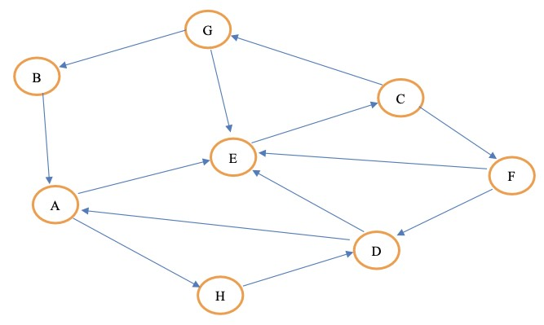

1. Represent this graph using adjacency lists. Arrange the neighbors of each vertex in alphabetical order.
   * list the triplets for this graph in the form (A, B, 1), where there is a edge from vertex A to vertex B;
   * Note that this graph is directed, unlike the one presented in class.

* **(A, E, 1), (A, H, 1)**
* **(B, A, 1)**
* **(C, F, 1), (C, G, 1)**
* **(D, A, 1), (D, E, 1)**
* **(E, C, 1)**
* **(F, D, 1), (F, E, 1)**
* **(G, B, 1), (G, E, 1)**
* **(H, D, 1)**

1. Trace the BFS execution by adapting the code to deal with a directed graph (remove lines 14, 15, and 16) and instrumenting it to print every time a vertex is visited and everytime a vertex is enqueued or dequeued.
   * Each time a vertex A is visited print: "Vertex A visited" and the current array V;
   * Each time a vertex B is enqueued print: "Vertex B enqueued" and the current queue Q;
   * Each time a vertex C is dequeued print: "Vertex C enqueued" and the current queue Q.

